TCS3351 Cryptography and Data Security
Tutorial 4
Modern Symmetric Ciphers-I (Feistel Cipher Structure, DES, Mutiple DES)

- Distinguish between the following:

- A block cipher and a stream cipher
- Diffusion and Confusion

- What kind of attack on double DES makes it useless? Explain briefly.

- Determine whether the P-box with the following permutation table is a straight P-box, a compression P-box, or an expansion P-box. Give the reason for your answer.
(i)
4 | 2 | 2 | 5 | 1 | 4 | 3

(ii)
5 | 7 | 9 | 1 | 2 | 8 | 4

(iii)
4 | 2 | 6 | 7 | 1 | 5 | 3

- The following table defines the input/output relationship for an S-box of size 3x2. The leftmost bit of the input defines the row; the two rightmost bits of the input define the column. The two output bits are values on the cross section of the selected row and column. Row and column numbers and inside elements are given in decimal.

 | 0 | 1 | 2 | 3
0 | 0 | 2 | 1 | 3
1 | 2 | 0 | 3 | 1

Identify the output (in binary) for the input (binary)
- 010
- 001
- 111

- With respect to Data Encryption Standard (DES), steps involved are given below.

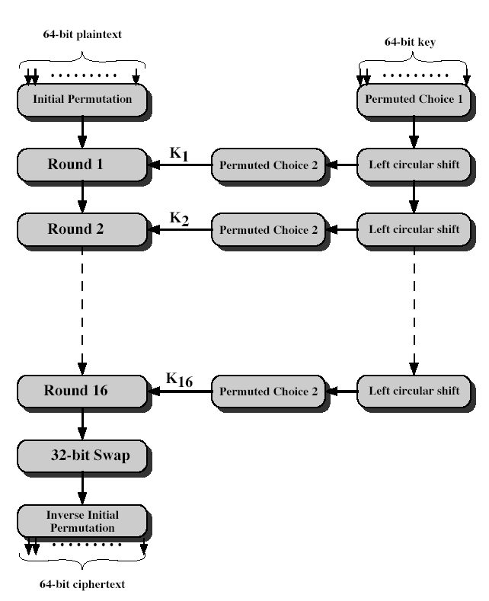

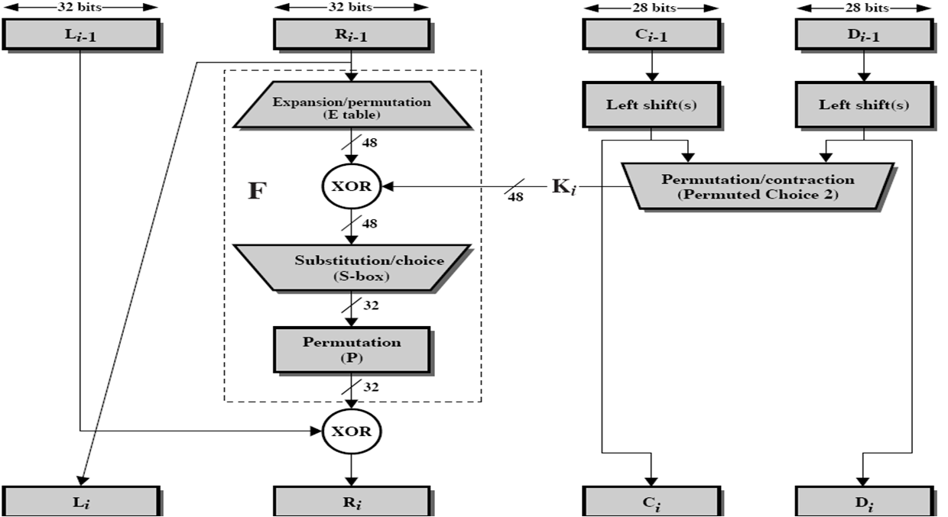
Details of one round in DES are given in the following diagram.

Answer the following questions, for the first round of DES. Refer to the above diagrams.
Assume the same bit pattern for the key and the plaintext, namely
1111 1110 1101 1100 1011 1010 1001 1000 0111 0110 0101 0100 0011 0010 0001 0000

- Derive K₁, the first-round sub-key.

DES Key Schedule Calculation
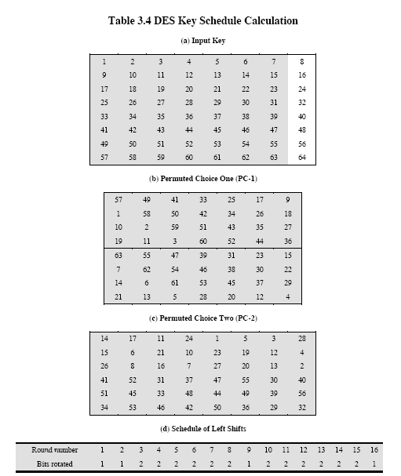

- Derive L₀, R₀.

Intial Permutation Table (IP)
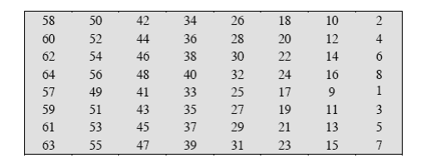

- Expand R₀ to get E [R₀].

Expansion Permutation (E) Table
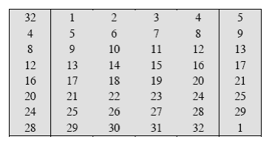

- Calculate A = E[R₀] ⊕ K₁.
- Group the 48-bit result of (iv) into sets of 6 bits and evaluate the corresponding S-box substitutions.

(vi) Concatenate the results of (v) to get a 32-bit result, B.
(vii) Apply the permutation to get P(B).

Permutation Function (P)

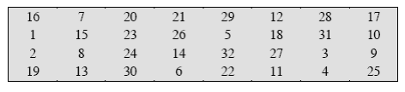

(viii) Calculate R₁ = P(B) ⊕ L₀.
(ix) Write down the intermediate ciphertext after the first round.

References:
1. Behrouz A. Forouzan, Debdeep Mukhopadhyay, "Cryptography and Network Security", Third Edition, McGraw-Hill, 2015.

2. William Stallings, “Cryptography and Network Security – Principles and Practice”,
Seventh Edition, Prentice Hall, 2017.

